Admissions Policy

Mission Statement
We strive to ensure a positive future for all our children and their families
Aims
Our mission is to provide early intervention through high quality Early Years practice for young children with autism and related conditions, delivered by experienced and dedicated staff.
To ensure that families access expert guidance and a range of support.
To lead the development of best autism practice through early intervention.
Admissions
In the Early Years Centre we cater for children aged between 2.5 to 5. Children do not require a diagnosis or referral; however, their main presenting need is autism or a related condition.
Our criteria for admission are based upon an assessment of the child’s needs matching the specialist provision we offer.
We operate a waiting list and children will be offered a place at the Principal’s discretion, depending on the need of each child and sessions that we have available. Once the application pack is completed, families will be added to the waiting list.
The Principal will determine what sessions are allocated according to the needs of the child.
Children funded other than by parents/carers, e.g. a local authority or school, will be charged on a cost recovery basis for each session provided by TRACKS autism.
For children funded by parents/ carers the charges for each session provided will be at a heavily discounted rate that covers around 50% of the cost of a session, dependent on the level of donations and government support from time to time.

As a charity TRACKS autism seeks donations and fundraises to provide subsidised early intervention for young children with autism and related conditions. Typically, each session will by for no more than 8 children with up to 6 staff.
Parental fees and voluntary contributions paid are non-refundable unless a month’s notice is given to inform us of absence.
Parents/ Carers must agree to give a period of a term’s notice when their child is to leave.
In the event the centre closing due to factors beyond our control, it will be at the discretion of the Trustees as to whether refunds will be offered.
For Parental Contributions see the attached schedule.
The Early Years Centre at Tracks autism is normally open for 39 weeks a year with sessions available: -
Monday – 9.30 – 12.30 Taster session for new children
Tuesday – 9.30am to 2.30pm Full day Reception aged children
Wednesday – 9.00am to 12.00 pm and 1.00pm to 4.00pm Standard session
Thursday – 9.00am to 12.00 pm and 1.00pm to 4.00pm. Standard session
Friday – Closed to families.
Sessions are between 3 and 5 hours long. The minimum number of sessions (apart from the taster session) is 2 sessions. Children attending only one session a week will not get the full benefit of what we offer and so are required to attend two sessions per week. Reception age children will be encouraged to attend on a Tuesday double session (as availability allows).
The Early Years Centre is on one level and so accessible to any child who has a disability/mobility issues.
We operate as an Early Years Centre providing access to the EYFS as well as a
provider of specialist education.
We usually offer children on the waiting list a feeder session on a Monday morning. If they are in a feeder group, they will be required to commit to accepting two sessions a week once they become available.
A copy of our Safeguarding Policy and other information about TRACKS autism is available on our website – www.tracks-autism.org.uk .

Signed by : Howard Bryant
Role : Chairperson
Date : Oct 2026

Parental Fees and Voluntary Contributions.

Parents can use part of their 15/30 free hours entitlement from the government.
This will reduce the cost per session when taking up the full services offer, ie £17 per hour minus £6.25 funded per hour (we receive £6.25 per hour from the Government when claiming funded hours).
Please see list of voluntary services included in full payment.
We are also able to access tax free childcare, if you are entitled to that.

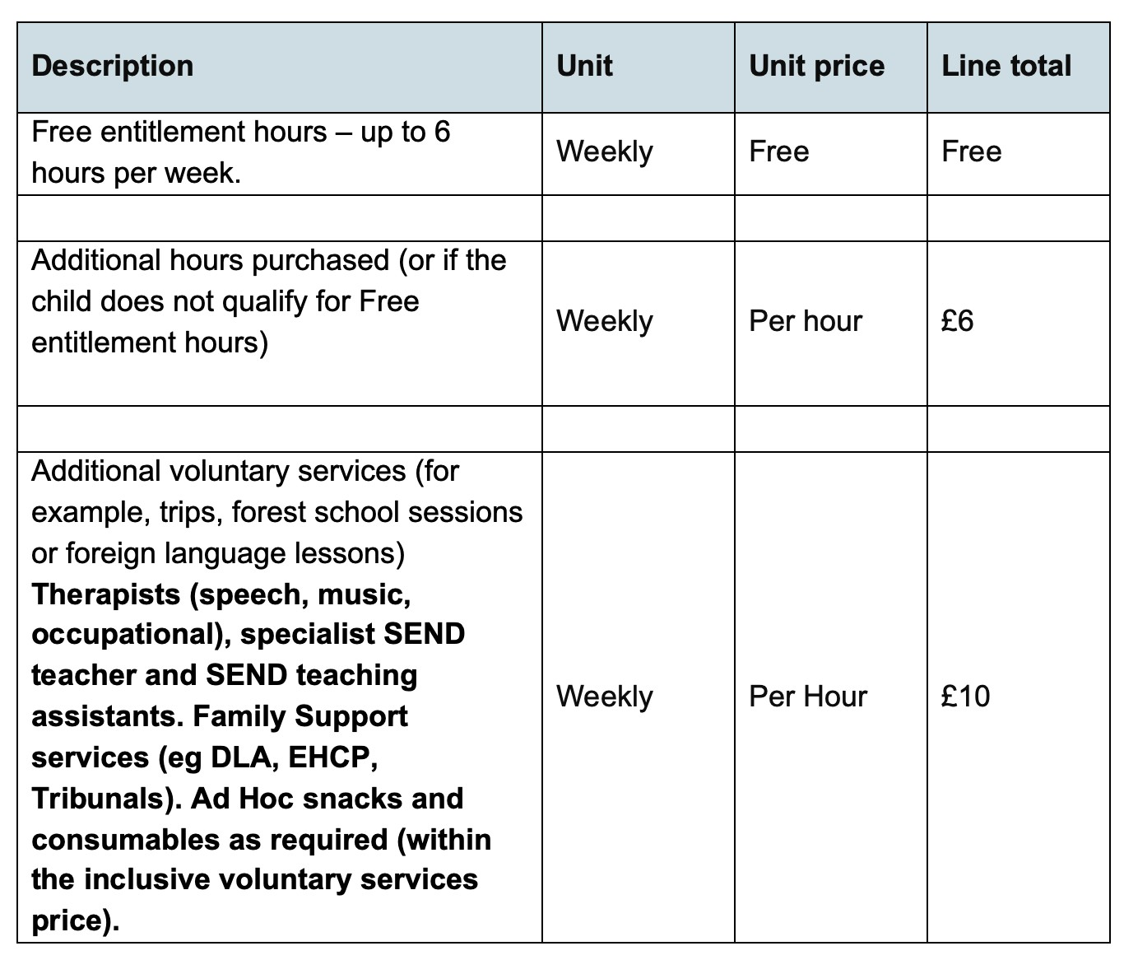

Voluntary contributions are detailed on the parental contract entered into prior to initial attendance

